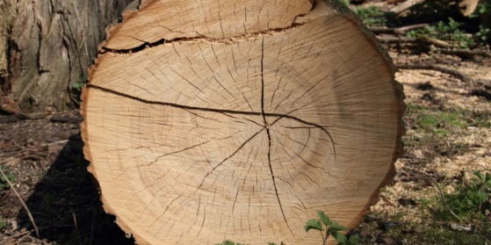

List selected UBA Publications
Virtual European Resources Forum 2020 online
November 03, 2020
www.resourcesforum.eu

Contact:

Mr. Christopher Manstein
German Environment Agency
www.resourcesforum.eu
erf@uba.de

Link List selected UBA Publications (status: 10/22/2020):

- Announcement new Factor X Book
- Environmental Criticality of Raw Materials
- Impacts of climate change on mining, related environmental risks and raw material supply
- International Environmental and Sustainability Policy During and After the Covid-19 Pandemic
- International paths for more resource efficiency - Policies and trends in selected countries
- ÖkoRess I Discussion of the environmental limits of primary raw material extraction (summary)…
- ÖkoRess II Comparative analysis of case studies for mining sites worldwide
- Regional and local optimisation of material flows and cycles
- RESCUE INFO Sheet
- RESCUE Resource-Efficient Pathways towards Greenhouse-Gas- Neutrality – Summary Report
- RESCUE Resource-Efficient Pathways towards Greenhouse-Gas-Neutrality - Executive Summary
- RESCUE Scientific Opinion: Resource-efficient Pathways towards Greenhouse Gas- Neutrality
- Substitution as a Strategy for Reducing the Criticality of Raw Materials for Env. Technologies
- The Green New Consensus: Study Shows Broad Consensus on Green Recovery Programmes
- The Use of Natural Resources: Report for Germany 2016
- The Use of Natural Resources: Report for Germany 2018
- Urban Mining – Resource Conservation in the Anthropocene

