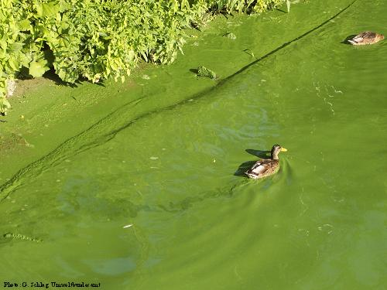
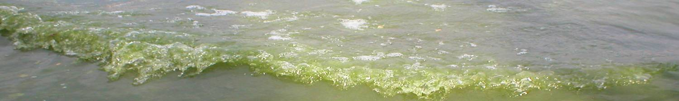
What are public authorities doing to protect us?

In Germany, most local authorities monitor bathing sites regularly. They

Three simple rules:
- If the water looks greenish-turbid, or if green scum floats on it, don’t swallow any water. Avoid aerosol e.g. through water-skiing.

- Be aware that some activities inevitably involve swallowing water:

- To check if the water is safe: walk in carefully, up to your knees, without stirring up sediment.
Can you still see your feet ?

Is it safe
to swim in this ?
What should I know about Toxic Cyanobacteria?
What can I do to avoid exposure?
Note: this flyer is not intended for direct use, but rather to be adapted locally, or translated, as adequate.

- issue information and warnings if cyanobacteria occur in moderate amounts and
- close the site temporarily if scums or mass proliferation are observed, or if more than 100 µg/L of microcystin are detected.

- children romping around in shallow shore areas where most skum accumulates,
- beginners frequently falling off a sailboard;
- sailing in small boats in rough weather.
- Closure should be limited to hazardous situations. After all, swimming and other recreational water activities water are healthy!
- You can consult the Federal Environmental Agency and your local health authority for further information !

Don’t swim here:
Swimming is OK here:
What can we do to prevent toxic cyanobacteria ?
The only effective prevention is to sufficiently reduce nutrient loading to the water-bodies, particularly phosphate. In Germany, this is mostly from excessive fertilisation in agriculture.

You can contribute by buying products from organic farming !
Phosphorus concentrations in many German water-bodies have been reduced by more than half during the past 2-3 decades, and indeed in some, cyanobacterial mass developments hardly occur anymore !

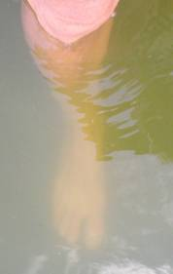
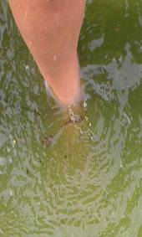

These 2 sites were just a few 100 m apart – so check the shore a bit upwind from a scum for a site with a better situation!

What are Cyanotoxins ?
Cyanobacteria contain a huge variety of substances. The effects of these on other organisms are known only for some. A few may prove to be valuable pharmaceuticals, others – the ”cyanotoxins” – are poisonous.
Neurotoxins from cyanobacteria are found more rarely, and seldom in concentrations high enough to be dangerous.
Liver toxins – called microcystins – are very frequent. They are found in more than half of all cases of cyanobacterial mass developments.
Estimates show that in extreme cases, they can be acutely dangerous if a small child swallows about half a liter of ”pea soup” type bloowm.
In most cases, concentrations are not high enough for a risk of acute poisoning. However, symptoms such as nausea, diarrhoea, vomiting, irritation of eyes, ears, throat may occur after recreational exposure to water with a high density of cyanobacterial cells, particularly if larger amounts of such water were swallowed.
Mass Proliferation and ”Blooms”
20 cm
What are Blue-green Algae
or Cyanobacteria?
Blooms as shown on the cover page consist of organisms often called ”blue-green algae”. Actually, this is not a good name for these organisms because
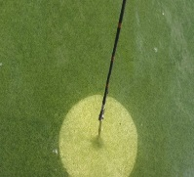
20 cm
Many species cause pronounced greenish turbidity
Some accumulate on the surface and form scums or ”algal blooms”

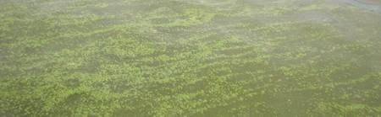

- They share more features with bacteria than with algae
- They rarely look blue – usually their blue pigment is masked by the green one, i.e chlorophyll-a.
- ”Cyanobacteria” is a better name for them !

Under a microscope you can recognise that the cells of some species aggregate to colonies (e.g. Microcystis) or to filaments (e.g. Planktothrix)
Blooms may become very dense, if wind and currents aggregate them along shorelines and in bays. This can look like ”pea soup”.
Microcystis
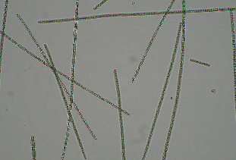
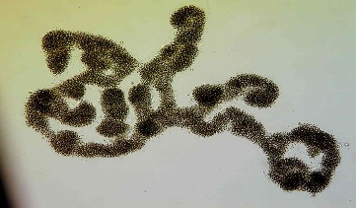
Where to ask or report ?
Are you concerned that you may have been exposed? Or do you want to report a bloom ?
Contact .....(enter appropriate local contact!)
Planktothrix

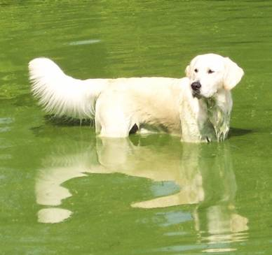
How Dangerous are Cyanotoxins ?
Toxic cyanobacteria cause a risk for human health chiefly if water that contains a lot of cyanobacteria is
repeatedly swallowed or aspired (i.e. uptake into nose and respiratory tract). This happens mostly
through intensive contact water sports, like water skiiing, sailboarding, diving, but also through sailing
in rough weather.
Upatke of cyantoxins through the skin is unlikely. However, some substances in cyanobacteria may
cause irritation, inflammation or allergic reactions of skin,
Acute danger is possible for children. Note that children tend to swallow more when they play intensively
(e.g. hand-stand under water, water-fights), particularly in shallow areas where scums acumulate !
For dogs and other pets, toxic cyanobacteria may be hazardous it they lick the cells out of their fur after
swimming in scum material. Sometimes dogs appear to be attracted to rotting scum material on the shore,
and eating this has actually killed dogs.

